Weight/Measurement
Your Logo Here
Tracking Chart

Client name: ______________________________________________________________

Measurements
Week Ending 1
Waist: _____________
Hips: _____________
Thigh: _____________
Chest: _____________
Body Fat: _____________
Weight: _____________

Week Ending 2
Waist: _____________
Hips: _____________
Thigh: _____________
Chest: _____________
Body Fat: _____________
Weight: _____________

Week Ending 3
Waist: _____________
Hips: _____________
Thigh: _____________
Chest: _____________
Body Fat: _____________
Weight: _____________

Week Ending 4
Waist: _____________
Hips: _____________
Thigh: _____________
Chest: _____________
Body Fat: _____________
Weight: _____________

Week Ending 5
Waist: _____________
Hips: _____________
Thigh: _____________
Chest: _____________
Body Fat: _____________
Weight: _____________

Record the following:
Chest: While standing, have the client breathe out and measure the chest circumference just above the nipple.
Waist: While standing, measure the client’s waist at its narrowest point. Alternatively, you can at the midway point between the top of the hip bone and the bottom of the rib cage.
Hips: Measure at the point where the client’s buttocks are protruding furthest.
Thigh: Measure just below the buttocks where the thighs are their thickest.

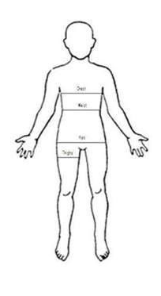

Starting measurements | Ending measurements
Chest: | Chest:
Waist: | Waist:
Hips: | Hips:
Thigh: | Thigh:
Body Fat: | Body Fat:
Weight: | Weight:

