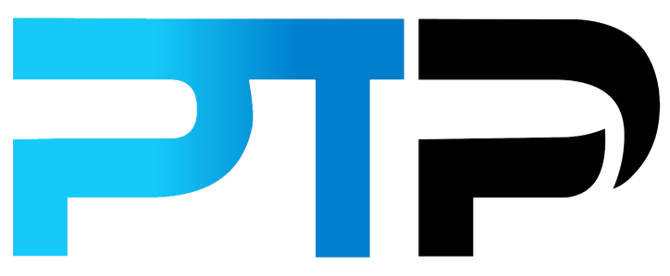
Takeaway Quiz Answers
Chapter 2

So here are the answers for our Chapter 2 takeaway quiz as well as the explanations. Let’s see how well you did. Note that the correct answers to the quiz questions are bolded.

____________________________________________________________________________

Question 1

Of the options below, choose one that is considered to be one of the four learning styles that we use to take in information.

- Accelerated
- Auditory
- Micro
- Asynchronous

Auditory learning is all about taking information in through listening. An auditory learner will read out loud or in their heads while working through a textbook as a way to use their auditory preferences to learn. Auditory learners love working in a group as well.

Question 2

Which of these learning styles best describes a person who learns through a “hands-on” approach?

- Tactile
- Auditory
- Visual
- Reading

Also called kinesthetic learning, a tactile approach to learning is very “hands-on”. It’s often a case of learning by doing which isn’t the easiest, especially with theory-heavy material.

Question 3

Which of these learning tools is the perfect way to learn difficult to remember terms or phrases?

- Flow chart
- SWOT analysis
- Mnemonics
- Summarization
Mnemonics are one of the many learning tools that you can use to remember difficult to learn terms or phrases. They can be used in a number of ways, for example making acronyms, using words, images and even models.
Question 4
Using a study guide is an excellent way to identify key concepts in your course work that you need to know and that will come up in the exam. True or false?
- True
- False
Study guides are a must for anyone who wants to pass their personal trainer certification. It helps to condense the information you need to know and understand. In essence, it pulls out all the critical information that appears in the coursework and gives you an overview of the key concepts found therein.
Question 5
Which of these below describes an important learning tool that you can use that makes use of spaced repetition?
- Flashcards
- Practice test
- Mnemonics
- Flowcharts
A spaced repetition flashcard system quickly works out which areas of the course work you are strongest in (you keep getting the answers right) and slowly makes those questions less frequent. Areas in which you give the wrong answers are identified as your weak point and therefore questions covering them become more prevalent.
In this way, weak areas within your overall knowledge are quickly improved as the system continually updates itself and continues to test you on concepts where you need the most work to improve. Overall, spaced repetition flashcards will save you hours on your overall study time.
Question 6
Which of these below is considered to be one of the learning styles that people use to learn new information and remember it?
- Deductive
- Assimilation
- Kinesthetic
- Chunking
Also called tactile learning, a kinesthetic approach to learning is very “hands-on”.
Question 7
Which of these below describes a learning style where charts, graphs and flashcards help the learner take in and process the course work easier?
- Tactile
- Auditory
- Visual
- Reading
A visual learner takes everything in through their eyes, for example, if they are reading from a text-heavy coursebook, they will try to visualize what they are reading and turn it into pictures in their minds. That’s not the only aspect a visual learner uses to process information. Charts, graphs, flashcards and other visual learning techniques help them process information and remember it. They also use color-coding techniques to further enhance the visual aspects of their learning.

Question 8
Ensuring that you spend some of your study time learning about anatomy is recommended before you take the exam. True or false?
- True
- False
For those of you who don’t have a fitness background, it’s important to understand that knowing anatomy is one of the core principles to help you achieve your certification. And while the textbooks do cover all the important information, it really doesn’t hurt to include some anatomy studies into your preparation.
Question 9
Which of these below will help determine if you are ready to take the final exam?
- Study guide
- Mnemonics
- Flashcards
- Practice exams
Taking at least one practice exam (but I would recommend more if possible) is essential before you tackle your certification exam. If you don’t pass your practice exam, you certainly ARE NOT ready. Start nailing those practice exams with ease and your knowledge base is big enough to see you through to your certification.
Question 10
From the options below, which of these is not one of the four learning styles that most people use to take in information?
- Kinesthetic
- Visual
- Auditory
- Facilitation
Kinesthetic, visual and auditory are learning styles that we identified in chapter 2 along with reading/writing. Facilitation is not a learning style that fits in with those.

